
ASR Config Server Updates

Presented to:
No
3/9/2021

Cognizant Microsoft Business Group
20 North Wacker Drive #530
Chicago, IL 60606

Notice of Confidentiality ©2021 Cognizant Microsoft Business Group All rights reserved.

IS SUBJECT TO THE TERMS OF THE COGNIZANT MICROSOFT BUSINESS GROUP NON-DISCLOSURE AGREEMENT. NEITHER THIS DOCUMENT NOR ITS CONTENTS MAY BE REVEALED OR DISCLOSED TO UNAUTHORIZED PERSONS OR SENT OUTSIDE THE AFOREMENTIONED COMPANY WITHOUT PRIOR PERMISSION FROM COGNIZANT
MICROSOFT BUSINESS GROUP.
Table of Contents
Summary 1
Upgrading Configuration server 1
Updating Mobility agent version on protected servers 1
Reactivating windows license on cs/ps 1

Summary
This document Is Intended to provide guidance on a couple of maintenance tasks that need to take place on ASR/AZM Configuration and Process servers (CS and PS), primarily during long lasting projects.

Upgrading Configuration server
It Is Important to keep the agent version within 4 releases of the most current version. For example, If the most recent version Is 9.40, you do not want to have any servers running any versions before 9.36. The main purpose of keeping the CS version within 4 versions Is to keep updates to a simpler process, because If It gets past 4 versions, an Incremental upgrade must take place to reach the newest version. For example, version 9.35 would first need to be upgraded to at least 9.36 before It could be upgraded to 9.40.
You can view the Agent Version of all CS connected to an ASR vault In the Azure portal by navigating to the Configuration Servers view. As shown in the screenshot below, ASR will always identify when an update is available or if the server is on the most recent version:
- In the Azure Portal, navigate to the ASR vault
- Site recovery Infrastructure
- For VMware & Physical Machines > Configuration Servers
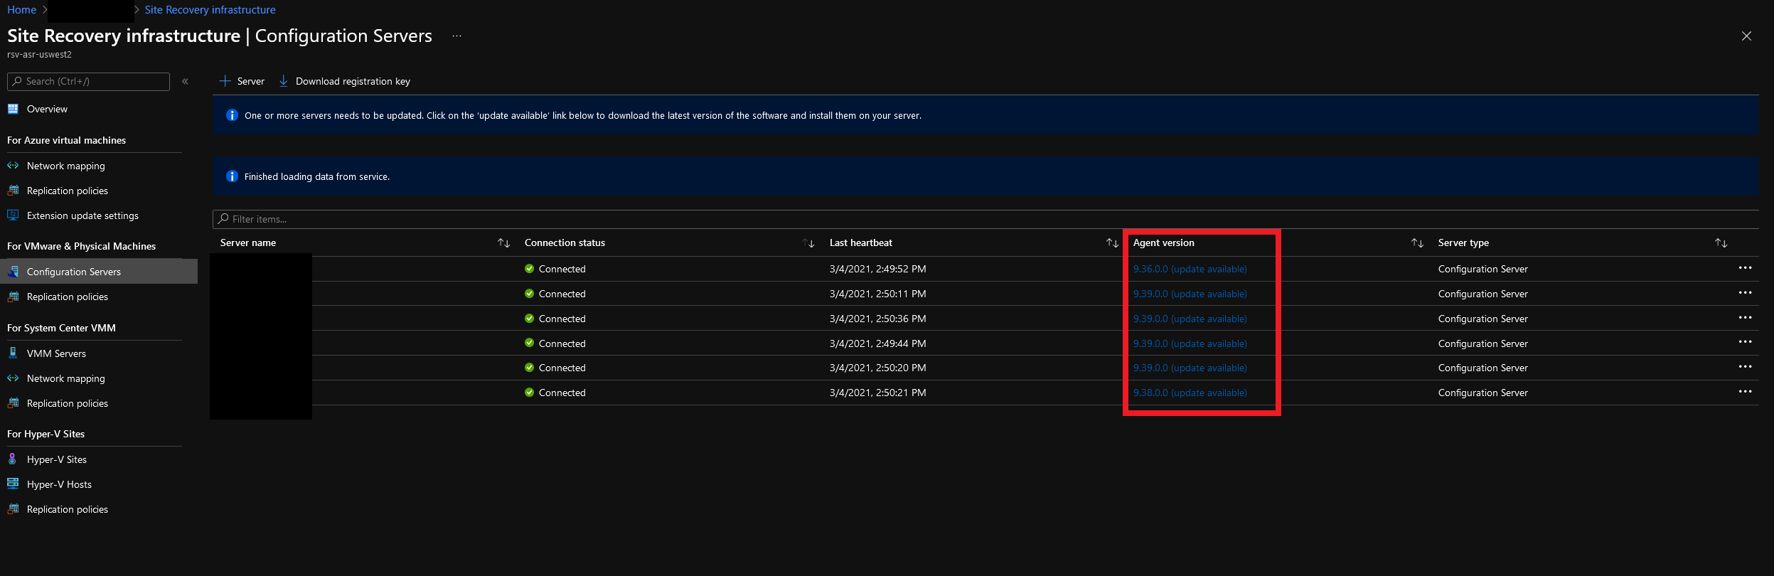

To perform the upgrade, you will have to download the new Installer files (~2GB) onto each server, or download them once and distribute a copy to each server If possible. It Is generally easiest to remote Into each server, open the Azure portal on each and download the agent files from there, as stated In the process below:
- RPD Into the CS/PS that you wish to update
- Open the Azure portal, and navigate to the Site Recovery Infrastructure | Configuration Servers view as shown In the screenshot above.
- Click the hyperlink (update available) on the line of the server you are on and wish to update.
- On the blade this opens, you can click on either download link to begin the download
  - You can choose to either "Run" or "Save" on the browser popup of the download
  - 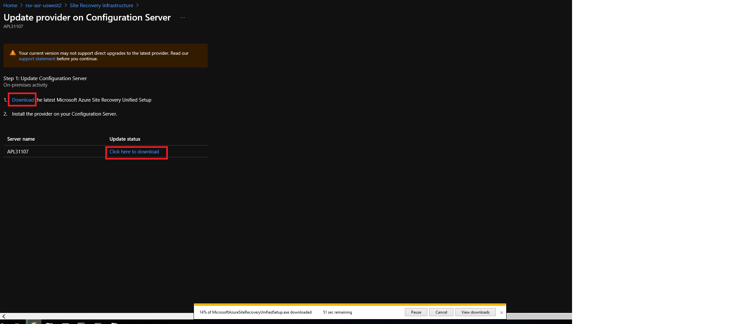
- Once the download Is complete and you have ran the downloaded .exe file, you will receive a popup asking to upgrade to the latest version, click yes
  - 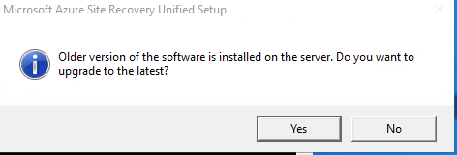
- At this stage, the Installer will run through the steps of upgrading the agent version and will need to be rebooted once complete. If any of the steps fail, you may click on the "Failed" status to get more Information and remediation steps before trying the Install again.
  - 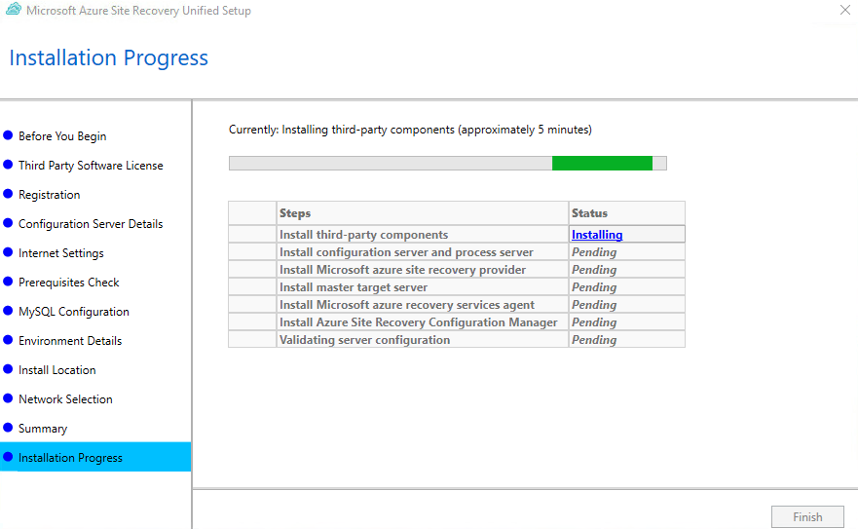

Reference Documentation: https://docs.microsoft.com/en-us/azure/site-recovery/vmware-azure-manage-configuration-server#upgrade-the-configuration-server
Updating ASR version when older than 4 versions

- To find an older version of the Unified Setup, visit this link and download a version that Is within N > 4 version of the currently Installed version: https://docs.microsoft.com/en-us/azure/site-recovery/site-recovery-whats-new
- Choose the link for the rollup that matches the version you want to download
- Choose the 3rd link down the page to download the UnifiedSetup.exe
- Continue with the Install as you would for the standard unified setup
- Complete the standard upgrade process once you are within 4 versions

Updating Mobility agent version on protected servers
When there Is a mismatch of the CS versions and the version of the mobility agent on protected servers, you will see a banner like this when viewing replicated Items In ASR.
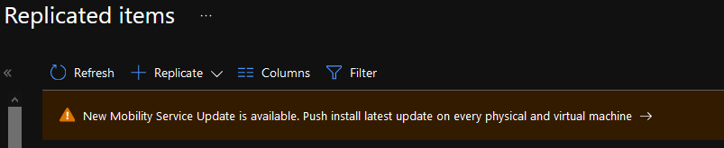
- To do a push Install update on protected Items click on this banner (note: you can also find this banner by viewing the protected Items of a specific CS server)
- Choose the machines you wish to perform the push Install update on
- Choose the credentials to be used for the push Install, you will normally choose the credentials that were used for the Initial push Install
  - 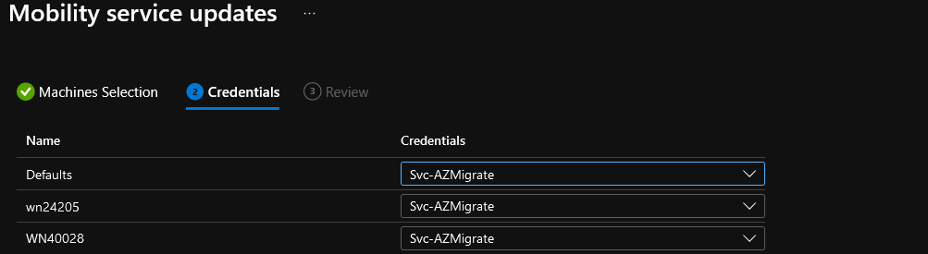
- Click next, then update.
Reference Documentation: https://docs.microsoft.com/en-us/azure/site-recovery/vmware-physical-manage-mobility-service

Reactivating windows license on cs/ps
If a CS/PS server has not been added to a domain or activated through a client's normal on-prem means, every 180 days the Windows license will expire. This can cause adverse effects, such as your CS/PS shutting down on Its own.
To resolve:
- Login to the CS/PS server
  - One way you can see the remaining time on the Windows license Is the overlay In the bottom right of the desktop
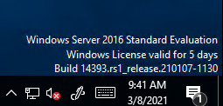
- Open an elevated Command Prompt
- Use the command below to extend/reactivate the windows trial license for another 180 days
  - Slmgr /rearm
  - You will receive a popup requesting a reboot, complete this when possible
  - 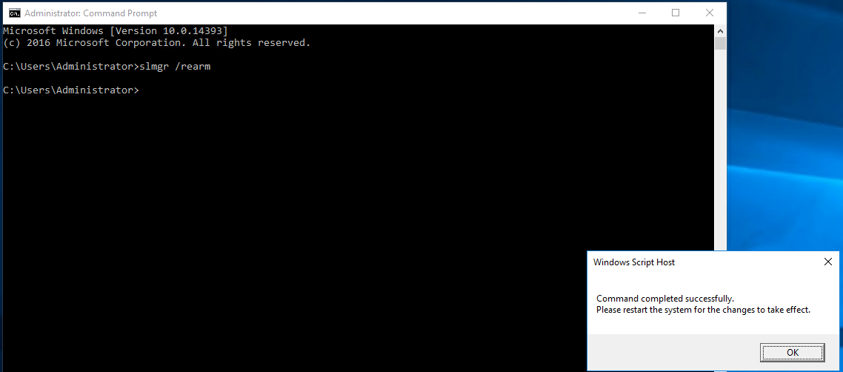

Post Failover Configurations

